# CU

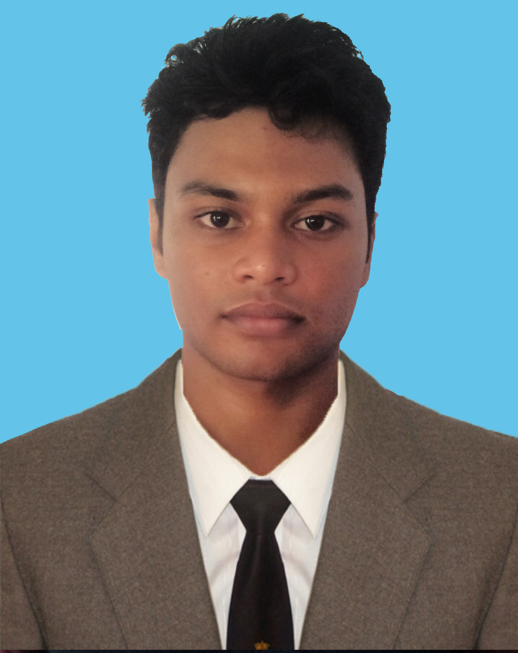

# CURRICULUM VITAE

**MEHEDEE HASAN.**

Flat No # 6B, House No # 21, Road No # 01,

Mohammadia Housing Ltd, Mohammadpur, Dhaka-1207

Cell: +880 1731430177

E-mail: [mhdrkb91@gmail.com](mailto:mhdrkb91@gmail.com)

# Career objective

* To build up my career in the field of some challenging post in any organization where there is immense scope to work and prove ones expertise and to maneuver positive contribution in the organization by sincerely accomplishing the duties and responsibilities assigned to me.

# Academic Qualification

**Master of Science (MSc) :**

Institute : Dhaka College.

Affiliated : Dhaka University**.**

Subject : Physics.

Result : Enrolled.

**Bachelor of Science (BSc) :**

Institute : Noakhali Govt. College.

Affiliated : National University**.**

Subject : Physics

Passing Year : 2014

Result : CGPA- 2.91 out of 4.00

**Higher Secondary Certificate(H.S.C) :**

Institute : Cantonment College Comilla.

Group : Science

Board : Comilla

Passing Year : 2009

Result : GPA- 5.00 out of 5.00

**Secondary School Certificate(S.S.C) :**

Institute : Alexander Pailot High School.

Group : Science

Board : Comilla

Passing Year : 2007

Result : GPA- 4.06 out of 5.00

# Computer Skills

* Microsoft Office Programs (Word, PowerPoint)
* Certified for 4 year Diploma in Computer Science & Technology.

# Other personal details

Father’s Name : MD. Salah Uddin

Mother’s Name : Suraya Begum

Date of Birth : 01-10-1990

Nationality : Bangladeshi (By Birth)

Religion : Islam

Sex : Male

Marital Status : Single

Blood Group : A +ve

National ID No : 19905117323000059

Permanent Address : Village: Sujan Gram, Post: Alexander,

P.S: Ramgoti. Dist: Lakshmipur. Post-Code: 3730;

# Language Ability

* English (Professional proficiency).
* Bengali (Native).

# Self Assessment

* Excellent negotiation, interpersonal communication skills.
* Effective presentation skills.
* Being able to interest with people at all levels & work as a team player.
* Like to take challenges & ready to work under pressure.

# Interests and hobby

* Travelling.
* Watching human attitudes in different situations.

I do declare that all the information mentioned above is true and correct to the best of my knowledge.

Signature